**How to upload your attendance**

1. Open the attendance manager
2. In the tab *Functions* select *Connect…*

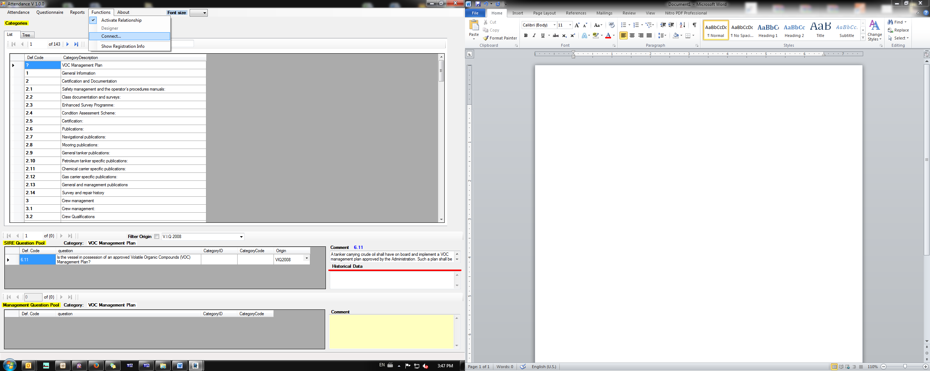

1. In the pop-up window use the below details

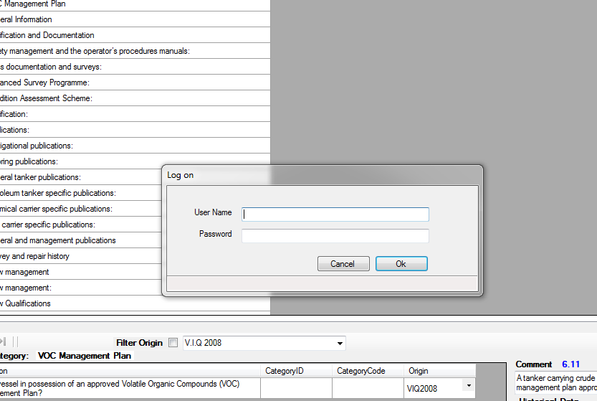

Username: Manager

Password:  ioniamng

1. Select again in the tab *Functions* the *Designer*

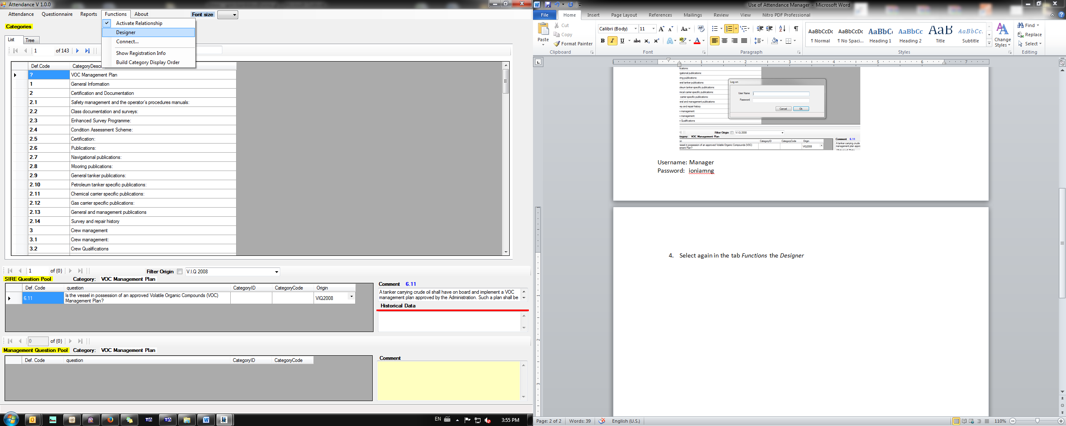

1. In the tab *Briefcase* select *Open*

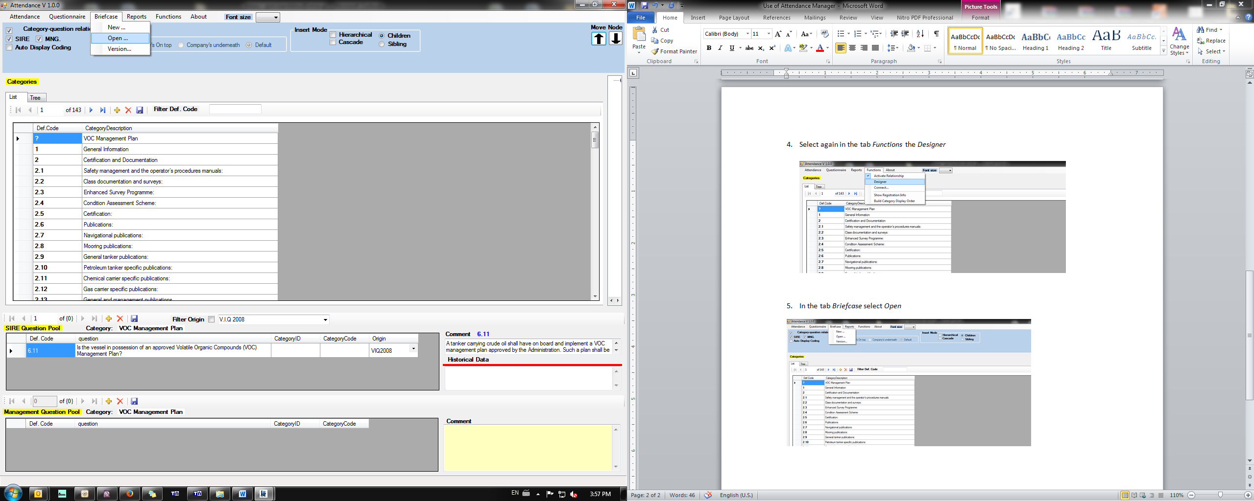

1. Navigate to the folder where your attendance file is available
2. Select the attendance and select *Transfer to Database*

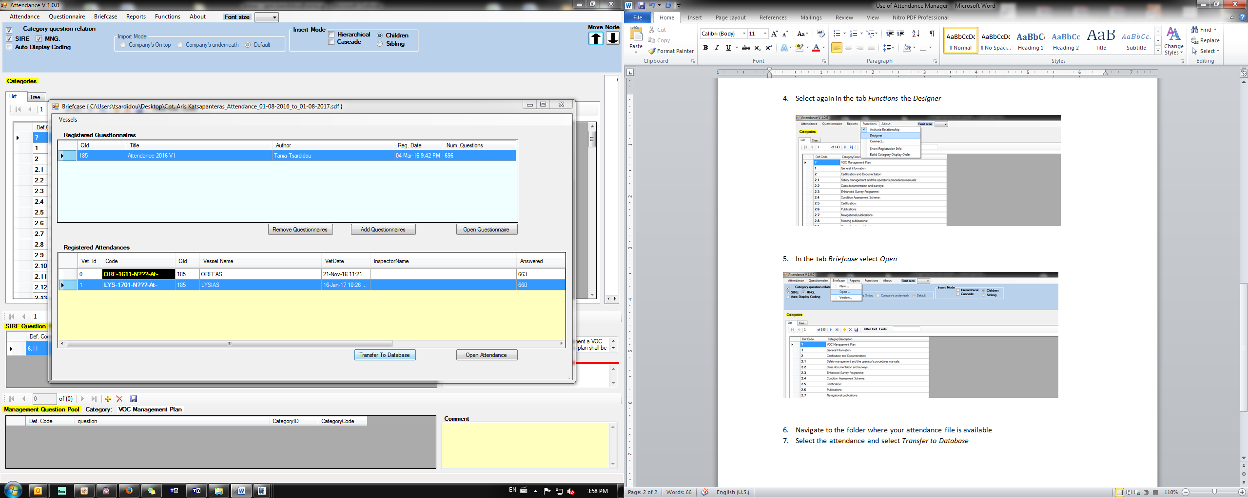

1. A pop-up confirmation will be appeared.

**How to create a new portable**

1. Follow the steps 1-3 as described above
2. In the tab *Briefcase* select *New…*
3. In the pop up window complete
   1. your name as you wish to be appeared in attendance manager
   2. the inspection type (ie attendance, vetting, etc.)
   3. the path where you wish the file to be saved (click on the dots on the right)

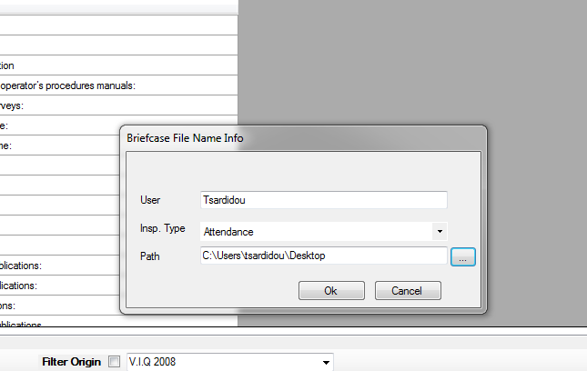

1. press ok and a confirmation will be appeared

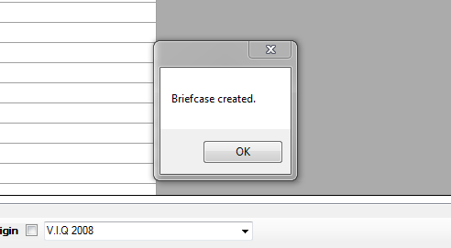

1. Select *Add Questionnaires*

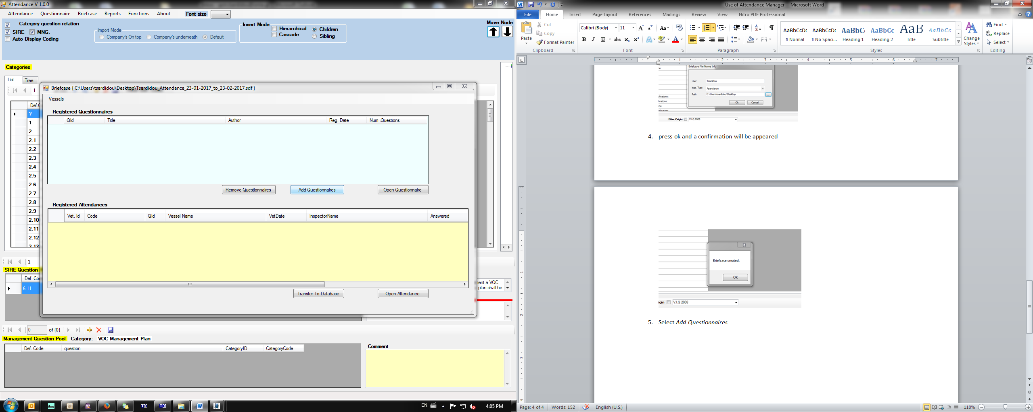

1. If attendance, select the most recent at the bottom (currently is the no 185 Attendance 2016 V 1), if vetting the 191 or 188 respectively

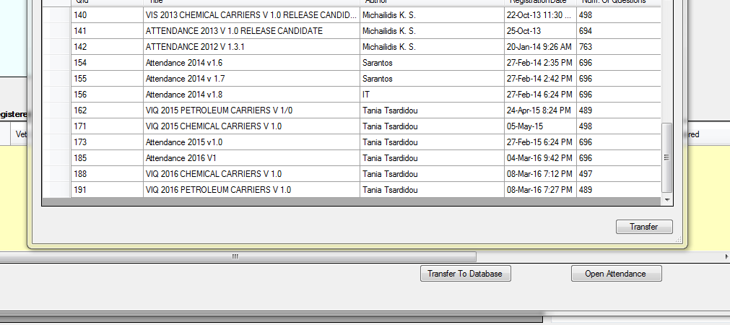

1. Select *Transfer*

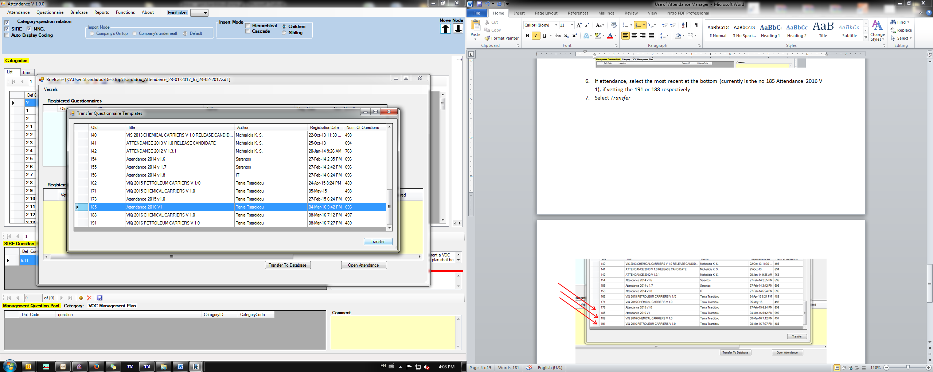

1. And this notification will be appeared

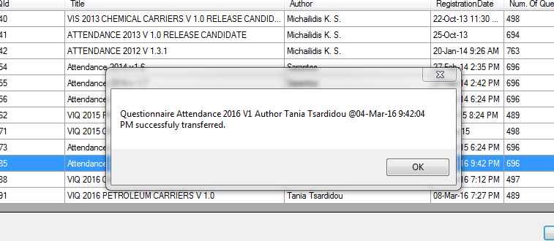

1. You can now close all the windows and the folder will be at your selected path.